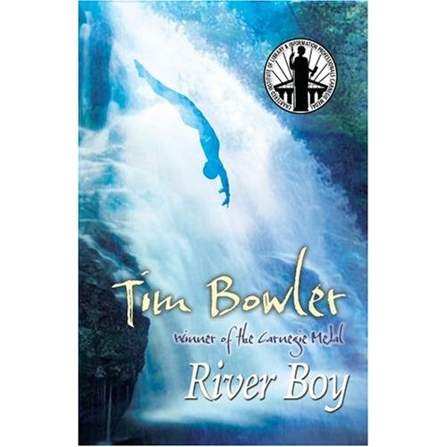
“River boy” is an exciting book with a lot of cliffhangers. At the beginning there’s not a lot of tension but more a description. Further in the book you get to know more about the characters, Jess, Grandpa, Mum, Dad, Alfred and the River Boy. There are a lot of different characters, young and old. Some stay strong, some talk a lot and others are very brave. This makes the story exciting. While you read the book it’s not just boring. At almost every end of a chapter there’s a cliffhanger. You really want to read further on. More close to the end it gets very thrilling, you want to know if everyone will succeed in their mission.
Jess, a girl your age, really likes swimming. She has a grandpa who is sick. But he stays strong to keep focusing on his life work called ´River Boy´. He really wants to finish it but has almost no time left. His life is almost over. His hands and arms hurt so much that he can´t finish his life work. He won’t go to the hospital. Jess feels something weird about the work and really understands how much this means for her grandpa. She gets involved with a mystery boy, she calls him “the River Boy”. Jess talks with him and says why she is unhappy. The River boy would only help her if she helps him. She accepts the deal. The River Boy helps her.
But will she understand it ? Will it work? Will Grandpa die before he finishes his life’s work? Will she help the River Boy?
If you want to know the answers … just read this exciting book.
I recommend you after you read this exciting book to start reading these books:
