The Akhenaten Adventure

A well-written book, about a subject that is rare. Djinns have been in myths and legends in several civilizations from a very early age. Also know as genies, they are not often written in novels. Why? Know one really knows, perhaps vampires and Sci-fi is what people are interested with now a days. However if you are one of those people that like a change in what you are reading this is the perfect book for you. Great descriptions and unexpected twists, this is a must have for people who enjoy reading books with humor but yet full of suspense leaving you craving for more.
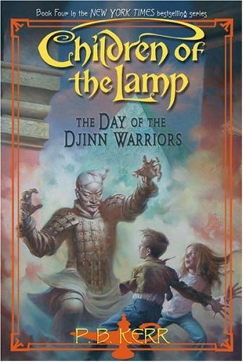
If you liked this, try these:
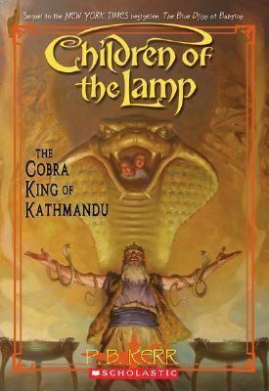
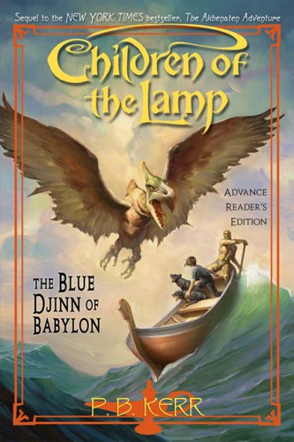

The blue The Cobra The Day The Eye
Djinn of King of of the Djinn of the
Babylon Kathmandu Warriors Forest

