You must read this book!
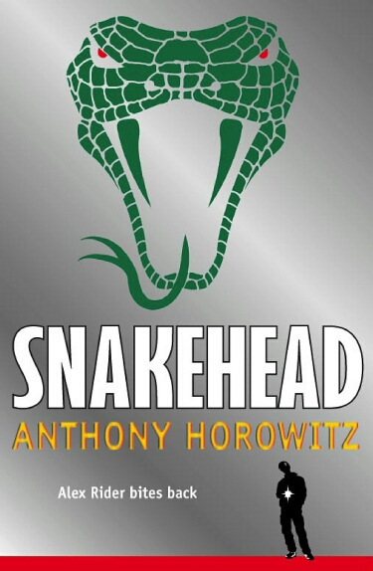
I have been reading quite a few books these past few months, but none of them seems to attract me and really making me focus on the text in the book. Fortunately, the book I have longed for has finally showed up. It is of course: Snakehead. Anthony Horowithz produces snakehead in 2007. This book is packed with action in every single chapter. Like the other books in the series, there’s always a mysterious person who pretends to be the good guy. Anthony Horowithz used a lot of time and thought on this book. He makes the text very lively using vivid imagery. Every single part of the book can let you make a movie in your brain. It is that magical! This is a MUST read! If you ever liked this book you might also like the rest of Alex rider’s series!
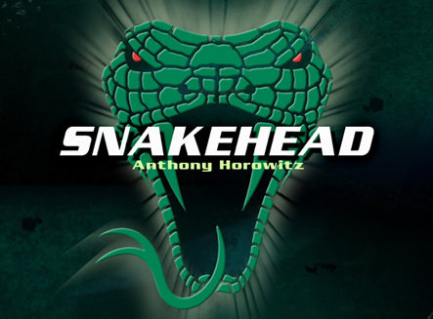
Rafter Chan

