Reds

Korea…
A country of spicy food
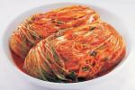
Red…
Full of passion
Red…

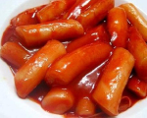
Kim-chi spicy
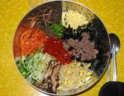
Bi-bim –bab spicy
Dduk-bbok-ji spicy

Football chanting, passion
Koreans, passion
I’m passion

Red is a color of passion
Red is a color of spicy food
Red is a color of me

