YOU MUST READ THIS

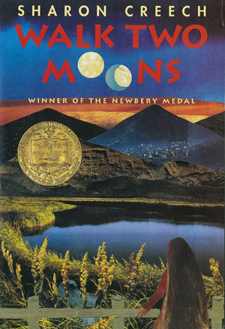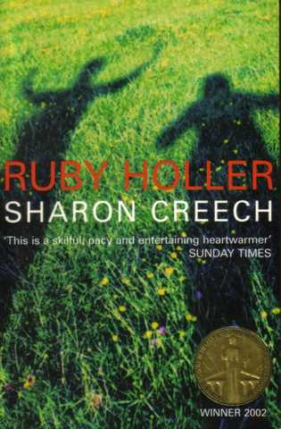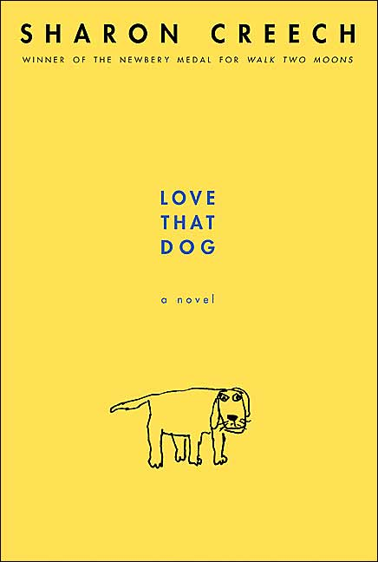 !!! BOOK !!!

WHY ????????????????

The book Ruby Holler by Sharon Creech is truly awesome. The basic story is about 2 children - who are brother and sister – get adopted from an orphanage. However, they are known as the most naughty kids there. The families who adopt them are very different from the other families. There are sure to be many adventures.

I may also add that this book won the 2002 Carnegie book awards. If you like this book (which I’m sure you will) you should read ‘LOVE THAT DOG’ or ‘WALK TWO MOONS’