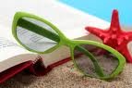
Summer Reads – Weebly Project

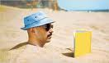
Exam week is over and summer is coming. What better way to spend your lazy, holiday days than with a book? We know you can’t last a WHOLE SUMMER HOLIDAY without some reading…
Sooo… welcome to the start of our summer reading project!

You have the choice of two tasks:

TASK 1: Compile a top 10 list. The books on your list should all have something in common e.g. ‘Top 10 Mystery Books’, ‘Top 10 Beach Books’ or ‘Top 10 Non-fiction Books.’ You do not need to have read all of the books yourself but you must find out about all the books from other students or teachers in school. You MAY NOT copy and paste a list from another website. You MUST include at least one line of blurb about the book.

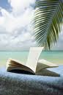
TASK 2: Compile an entry for a FEATURE BOOK. Choose one book that you have read and that you think other people MUST read. You should write a brief, persuasive outline of why people MUST read this book. At the end, you also need to include other books people might like to read if they have read this book e.g. ‘If you liked this, try this:’

Your teacher will show you some examples.

Get the sunglasses on and get reading!

